

SA Project
UBER System Design

Student Name | BN
Abdelrahman Wahid Abdallah Ali | 17
Abdelrahman Mamdouh Mohamed | 16
Ahmed Ragab Mahmoud | 3
Aya Mohamed Sayed | 4
Shams Hesham Elsayed | 12

This project was supervised by Dr. Rania Zeidan

Table of Contents

Abstract | 2
Introduction | 2
Event Table | 3
Use Case Diagram | 7
Use Case Description | 8
State diagrams | 16
activity diagrams | 18
Sequence DIAGRAM | 25
DFDs | 25
Gantt CHART | 25
Questionnaire | 25
Conclusion | 25

Abstract
The Uber Transport System is an intelligent, app-based platform designed to facilitate seamless, on-demand transportation services. It connects passengers with available drivers in real time, enabling users to request rides quickly and efficiently from virtually any location.
The system supports user registration, ride matching, route planning, communication, and payment, all within a unified digital environment. It ensures smooth interaction between passengers and drivers while maintaining oversight through administrative control and reporting features. By leveraging modern mobile technologies and location-based services, the system offers a reliable and scalable solution for urban mobility challenges.

Problem Description – Uber – Transport System
This system aims to provide a smart transportation solution through an electronic application that allows users to request a car anytime and from anywhere. The interaction with the system begins when the user registers as either a driver or a passenger.
In the case of driver registration, the user is required to submit essential documents such as a valid driver’s license, car insurance, car model, type, color, and license plate number. Once submitted, these documents are reviewed by the system administrators before the driver account is approved. After successful registration(acceptance) and login, drivers can update their availability status to indicate whether they are ready to accept ride requests or not.
For passengers, registration is completed by providing a phone number or email address. If registered using email, a confirmation message is sent to activate the account. If using a phone number, a verification code is delivered via SMS. Once registration is complete, the passenger may add a recovery email address and update personal details including first name, last name, and payment information. These details can be edited at any time.
After successful login, the passenger can inquire about a trip by setting the current location (via GPS or manual input) and entering the desired destination . Upon this inquiry, the system displays a list of available cars nearby, along with information about car type, condition, availability of air conditioning, and an estimated initial fare. Based on this information, the passenger selects the most appropriate ride and sends a request, which is sent to all available drivers based on the chosen criteria.
Once a driver accepts the ride, the system displays the driver’s details to the passenger, including name, rating, car type, car color, license plate number, and the number of completed rides. Additionally, the estimated arrival time(source) and the real-time car location on the map are shown. The passenger also has the option to contact the driver via call or message. Prior to the driver’s arrival, both the driver and the passenger have the right to cancel the trip, if needed.
When the driver arrives at the pickup location, the ride officially begins upon confirmation by the passenger. At the end of the ride, the system provides payment options: cash or credit card. In case of credit card payment, the Visa card number, expiration date, and CVV code are securely stored in the system, using modern encryption techniques to protect user privacy. If cash is chosen, the driver confirms receipt of the payment, (driver balance) .
Following the trip, both parties have the option to rate each other using a five-star system and leave comments at the same time, which could be either compliments or complaints. This feedback is utilized to improve the overall quality of the service and build trust between users.
From the administrative side, the system provides the administrator with full monitoring capabilities over all activities. The admin can activate or deactivate user accounts, edit user data, and intervene in case of complaints or trip cancellations. Additionally, the Admin request a daily report that includes the number of completed rides, cancellations, user complaints, and ratings. These reports help in evaluating performance and making strategic improvements to enhance user experience.

Event Table
EVENT NUMB-ER | EVENT NAME | TRIGGER | SOURCE | USECASE | RESPONSE | DESTINATION
1 | driver register to the system | User's Information  a driver's license, car insurance, car type, color, license plate number, and model  driver registration request | Driver | Register a new  Driver | - approval or rejection message | Driver
2 | passenger register to the system | User's Information  personal information such as phone number or email address is entered  Passenger registration request | Passenger | Register a new Passenger | - a confirmation message | Passenger
3 | Passenger  update account information | - Update Request  - passenger's Info(first name, last name,  payment details) | - passenger | Update user's Profile | - notification to confirm the Update | passenger
4 | passenger  inquire a trip | - passenger  source location  - passenger destination | - passenger | Inquire a trip | - the app displays a list of available cars in the area  - car available information  (The car type, condition, air conditioning availability, and an initial fare estimate) | - passenger
5 | passenger  request a car | - The passenger chooses the car and price that suits them  - Trip's Info  - ride request | - passenger | Request a Car | - a ride request is sent to available drivers in the area  - the passenger sees detailed information about the driver  - Driver accept /refuse request | - Driver  - passenger
6 | Ride cancellation | Cancelation request | User  Driver or Passenger | cancel the ride | notification to confirm the cancelation  returned fees  if time of cancelation >2min or large distance | User  Driver or Passenger
7 | User want to Pay the ride | - passenger's credit card Info  - Payment request  - Ride completed | passenger | Pay the Ride | - notification to confirm the Payment | passenger
8 | Rate another party | - rate request (Feedback)  - Ride completed | User  Driver or Passenger | Rate The User | - Updated rate (rate and feedback) | User  Driver or Passenger
9 | Admin handles complaints or ride issues | Complaint submitted or cancellation occurs | Administrator | Take action on issue | - Action applied (e.g. warning, suspension, feedback sent)  - Notification Message for Modification  - Updated user profile | User  Driver or Passenger
10 | Report generation | Administrator request | Administrator | Generate report | information  About system | Administrator

The system consists of the following Use Cases
- Registe a new Passenger
This use case is initiated when a new passenger registers in the system. The passenger’s information is stored in the system database to enable tracking of rides, payments, and any related issues. Upon completion of the registration process, the passenger receives a confirmation message.
- Registe a new driver
This use case is triggered when a new driver registers in the system. The driver’s license and vehicle information are reviewed, after which the application is either approved or rejected based on the verification outcome.
- Update Passenger Profile
This use case is triggered when a passenger requests to update their information in the system. The passenger can modify personal details, and payment information. Once the updates are submitted, the system sends a confirmation notification to the passenger.
- Inquire a trip
After logging into the system, the passenger can request a ride by entering their current location and desired destination. Based on this input, the system displays a list of available cars within the passenger’s coverage area.
- request a car
After viewing the available cars in their coverage area, the passenger selects a trip based on their preferred car type and price. The ride request is then broadcast to all available drivers in the vicinity, and the system waits for one of them to accept the request.
- Cancel a ride
While waiting for the driver, the passenger has the option to cancel the ride. Similarly, the driver can cancel the trip before reaching the pickup location. However, if more than two minutes have passed since the ride request or if a significant distance has already been covered, cancellation fees may apply to either party.

- Pay the ride
At the end of the ride, the passenger is prompted to make a payment. They can choose between credit card payment or cash payment, based on their preference.
- Rate user
At the end of the ride, both the driver and the passenger have the option to rate each other on a scale from one to five. Additionally, each user is given the opportunity to leave a comment, whether it's feedback or a complaint.
- Take Action on issue
In this use case, the administrator exercises their authority to monitor and manage various aspects of the system, including rides, complaints, and other operational issues. Upon identifying any problems, the admin can take appropriate actions such as editing user information, suspending accounts, or issuing warning messages.
- Generate report
At the end of each day, the system automatically generates a comprehensive report summarizing key activities, including completed and canceled rides, user complaints, and ratings. This report helps the administrator monitor overall system performance, identify recurring issues, and make informed decisions to enhance service quality.

Use Case diagram
A use case diagram is a behavioral diagram that illustrates the interactions between users (actors) and the system. It shows the system's functionality from the user's perspective by outlining the key use cases and how each actor engages with them. In our system, the use case diagram highlights the main roles and their corresponding actions.

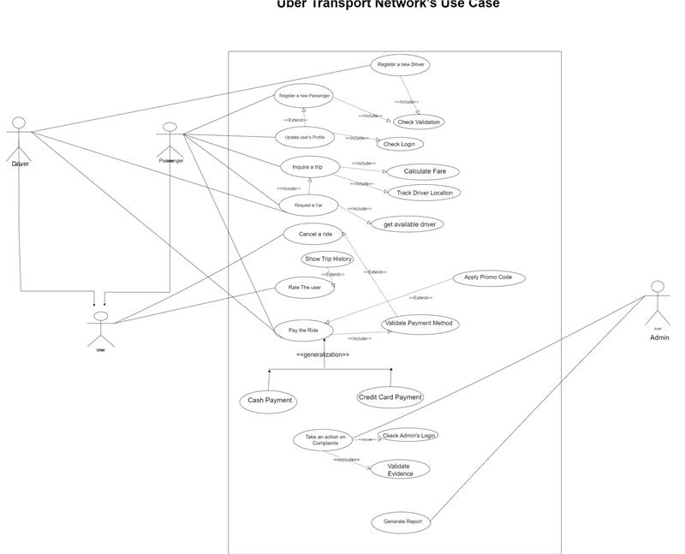

Use Case Descriptions
Use case name : | Register a new Driver
Scenario: | A new driver registers in the system.
Triggering event: | Driver submits registration documents and details.
Brief Description: | The driver provides required documents (license, car insurance, car model, type, color, and license plate number.), and the system admin reviews them for approval.
Actors: | Driver
Related use cases | need “check validation” to validate driver documents (validate document format , verifies authenticity and confirm phone number)
Stakeholders: | Driver , system Administrator
Preconditions: | - The driver has a valid driver’s license, car insurance, and a registered car.  - Driver does not already have an active account.
Postconditions: | If Approved:  - Driver account is activated.  - Driver is added to the system database.  - Driver can log in and update availability status to appear in available drivers list.  If Rejected:  - Driver receives notification with reasons.  - Driver can resubmit corrected documents.
Flow of Activities: | Driver | System
 | - Submits driver’s license, car insurance, model, color, and plate number.  - Receives approval/rejection notification.  - Update availability states | - Check validation  - Stores data and notifies admin for review.  If approved:  - Activates account.  - Add the new driver to data base of the system  2.3 Notifies driver  3.3 allows updates
Exception conditions: | - Invalid Document Format(driver’s license, car insurance):  System rejects upload and prompts for correct files (pdf).  - Expired License/Insurance:  Validation fails and driver must renew documents.  - Duplicate Account:  System detects existing account and blocks registration.

Use case name : | Register a new Passenger
Scenario: | A new passenger registers an account in the system.
Triggering event: | Passenger enters phone number or email.
Brief Description: | Passenger provides contact info then system sends verification code/email and upon successful verification, the account is activated.
Actors: | Passenger
Related use cases | “Update Passenger’s Profile” and “check validation”.
Stakeholders: | Passenger
Preconditions: | - Passenger has valid email or phone number.  - Passenger does not already have an active account.
Postconditions: | - Passenger is added to the system database.  - Account is activated  - passenger can log in and update his info
Flow of Activities: | Passenger | System
 | 1.Enters email/phone.  2.Enters verification code.  3.Enters first and second name, phone number and payment details(optionally) and email (optionally) | 1.1 validate email or phone number  1.2 Checks for duplicate account.  1.3 Sends verification code.  2.1. Verifies code matches sent code.  2.2. If correct:  Ask for passenger info  3.1check validation:  - Activates account.  - Adds passenger to DB.  - notifies successful registration.
Exception conditions: | - invalid email or phone number:  User enters valid email or phone number.  1.2 Duplicate Account:  System displays: "An account already exists with this email/phone." ; passenger enters new or not registered email or phone number  1.3 verification code sending Failure:  System notifies passenger: "Failed to send code. Please try again later."  - Verification Code Issues:  Code Expired: System allows resend (max 3 attempts).  Wrong Code: passenger enters code again and System blocks after 3 failed attempts (temporarily locks account).  3.1 Invalid Payment Info:  Card number fails validation → system displays "Please check card details"; passenger try to enter card number again  Expired card → "This card has expired"; passenger enters another card

Use case name : | Update Passenger’s Profile.
Scenario: | Passenger updates their personal or payment information in the system.
Triggering event: | Passenger requests profile update.
Brief Description: | Passenger modifies name, payment method, etc.; system confirms changes.
Actors: | Passenger.
Related use cases | "Pay the Ride" (uses updated payment info), “Register Passenger” (prerequisite for having a profile), “check validation” for validate payment method updates.
Stakeholders: | Passenger
Preconditions: | - Passenger has an account.  - Passenger must log in.
Postconditions: | - Profile changes saved to database  - Profile is updated
Flow of Activities: | passenger | System
 | 1.chooses edit profile  2.Edits fields  3.Confirms update.  4.receives confirmation | 1.1 Displays current profile info  2.1 Validates format.  3.1Verifies all entered data  3.2 Updates database  3.3 Sends confirmation
Exception conditions: | 3.1 Invalid Payment Info:  Card number fails validation → system displays "Please check card details"; passenger try to enter card number again  Expired card → "This card has expired"; passenger enters another card  3.1invalid email or phone number:  User enters valid email or phone number.

Use case name : | Inquire a Trip
Scenario: | Passenger checks available rides.
Triggering event: | Passenger enters pickup/destination.
Brief Description: | User chooses source and destination locations and System shows nearby cars with fare estimates and details.
Actors: | Passenger
Related use cases | “Register a new Passenger“ Preceding use case.  “Request a Car” Subsequent use case.  “Calculate Fare” for calculating estimated fare based on car type ,trip distance and other factors .  “Track Driver Location”
Stakeholders: | Passengers, Drivers.
Preconditions: | - Passenger is logged in  - GPS/location enabled.  - Available cars exist in nearby area.
Postconditions: | List of available cars displayed along with car type, condition, availability of air conditioning, driver rate, and an estimated initial fare.
Flow of Activities: | passenger | System
 | - Enables GPS or choose manual option to set pickup location.  - Sets destination locations. | 1.1 validate source locations:  Valid locations.  Checks service area coverage.  1.2 Queries driver database(Check availability)  2.1 validate destination locations:  Valid locations.  Checks service area coverage.  2.2 Estimates intial fares for each car type and add it to validate car lists.  2.3 Display cars available and car characteristics and intial fares.  2.4 Track drivers’ location and display by the nearest and cheapest.
Exception conditions: | 1.1 Invalid source addressalert message “invalid address reenter or use GPS ”  1.2 driver’s GPS is disabled so system can’t track his location notifies driver to turn on GPS when being available.  2.1 Invalid destination addressalert message “invalid address reenter the destination location”.  2.2 driver’s state changed update displayed available list  2.2 No cars available → System suggests retry later or try another source location.

Use case name : | Request a Car
Scenario: | A passenger requests a ride after selecting a suitable car from available options.
Triggering event: | The passenger selects a car and confirms the ride request.
Brief Description: | The passenger chooses a preferred car from the list of available options, and the system sends the request to nearby drivers. Once a driver accepts, the passenger receives driver details and trip information.
Actors: | Passenger
Related use cases | - Inquire a Trip (Preceding use case)  - Get available driver handles requests by send request by the nearest available driver with highest rate and handles multiple drivers’ request acceptance at the same time.
Stakeholders: | Passengers ,Drivers
Preconditions: | - The passenger is logged in.  - Passenger has inquired the trip
Postconditions: | - A ride request is sent to drivers.  - The passenger sees driver details upon acceptance.  - The trip is initiated when the driver arrives and trip state updated (ongoing).  - Update driver availability (busy)  - Track the ongoing trip (current location , estimated time to arrive , time passed since driver’s acceptance)
Flow of Activities: | passenger | System
 | - Selects a car and fare estimate.  - Waits for driver acceptance.  - Receives driver details  - (Optional) Contacts driver via call/message. | 1.1 Sends ride request to available drivers.  2.1 Notifies passenger when a driver accepts or cancels drivers’ request.  2.2 in case of acceptance system updates driver availability to busy  3.1 Views driver details (name, rating, car info, ETA).  3.2 Updates real-time driver location on the map.  4.1 use End-to-end encryption for security of the communication and trip.
Exception conditions: | 2.1No acceptance in 2 min expired request and system try again or auto cancels the trip request after 3 trial and notifies passenger.  - Multiple drivers’ acceptancethe system chooses one and cancels the other and notifies drivers.

Use case name : | cancel the ride
Scenario: | A user (driver or passenger) cancels an ongoing ride request
Triggering event: | User sends cancelation request
Brief Description: | User sends a cancelation request and System notifies the other party and logs cancellation.
Actors: | Passenger, Driver
Related use cases | ” Take action on issue” System administrator changes the rate of users who cancels requests frequently.  " Update Passenger’s Profile" or “validate payment”
Stakeholders: | Passengers, Drivers, System administrator.
Preconditions: | Ride is accepted but driver does not arrive the source location.
Postconditions: | - Ride is canceled  - Penalty may apply.  - Update drivers availability (available)
Flow of Activities: | Passenger | Driver | System
 | 1. Cancel Ride request.  2.Write cancellation reason(optional)  3.Confirm cancellation | 1. Cancel Ride request.  2.Write cancellation reason(optional)  3.Confirm cancellation | - Verifies cancellation eligibility:  - Time since request <= 2mins and small distance has been covered by the driver (No fees)  Time >2min and large distance has been covered by the driver (fees)  - Check that trip has not started  1.2 calculate fees  1.3 View fees  3.1 system make logs and sends it to system administrator to be reviewed  3.2 Notifies other party and updates trip status (canceled) and driver state(available)  3.3 apply fees :  Check card if available , debit fees  In cache payment add fees in the next ride | - Verifies cancellation eligibility :  - Check that trip has not started  3.1 system make logs and sends it to system administrator to be reviewed  3.2Notifies other party and updates trip status (canceled)  3.3Update driver state(available)
Exception conditions: | - no payment info for handle fees system asks user to enter payment info  3.3 if passenger refuses payment ,system administrator suspend his account

Use case name : | Pay the Ride
Scenario: | Passenger pays after trip completion.
Triggering event: | Ride completed and arrive destination location
Brief Description: | Passenger selects cash/card, system processes payment. In case of cache, driver confirms payment. In case of credit update driver balance.
Actors: | passenger
Related use cases | “Validate payment method” and “Update Passenger’s Profile.”
Stakeholders: | Passenger, driver.
Preconditions: | In case of credit card payment method:  - Passenger has valid bank account and credit card  - Driver has valid bank account  - Credit services are available
Postconditions: | - The passenger’s bank account will be debited  - The Driver’s bank account will be updated  - Payment confirmation  - trip state changes to (paid)
Flow of Activities: | passenger | System
 | 1. Passenger send payment request.  2. Selects payment method (card/cash).  3.confirm payment | 1.1Calulates final fare  1.2Ask for payment method  2.1 Processes payment (check there is valid card on the account) or prompts driver to confirm cash.  3.1 update trip as paid
Exception conditions: | 2.1 Invalid Payment Info:  Card number fails validation → system displays "Please check card details"; passenger try to enter card number again  Expired card → "This card has expired"; passenger enters another card.  If not solved system asks passenger to cache payment if not available, driver and passenger Agreement on bank transfer to drivers account or to pay later using another method

Use case name : | Rate The User
Scenario: | Driver/passenger rates each other after the ride.
Triggering event: | Users want to rate or complain.
Brief Description: | Driver/passenger submits rating (1–5 stars) and give each other feedback.
Actors: | Driver, passenger
Related use cases | Take action on complaints
Stakeholders: | Passengers, Drivers, system administrator
Preconditions: | Ride is completed.  Payment is completed
Postconditions: | - Rating is saved; average score updated  - Update user profile and database
Flow of Activities: | passenger | Driver | System
 | 1. Selects rating and adds comments. | 1. Selects rating and adds comments. | 1.1 update database  1.2 Updates profile ratings and stores feedback.  1.3 notifies system administrator for reviewing
Exception conditions: | 1.1 comments that contradicts policies system rejects them and notifies user and system administrator

Use case name : | Take action on issue
Scenario: | Admin resolves disputes or deactivates accounts.
Triggering event: | Complaint submitted or cancellation occurs.
Brief Description: | Admin reviews issue and takes appropriate actions.
Actors: | system administrator
Related use cases | Validate Evidence: Admins verify chat logs/GPS data before acting.
Stakeholders: | Admins, drivers, passengers.
Preconditions: | - Complaint exists in the system.  - Cancellation reasons  - Logs of issues
Postconditions: | - Action taken (e.g., warning, account deactivation).  - Updates related to action taken
Flow of Activities: | system administrator | System
 | 1.view complaints and logs Inbox.  2.Reviews complaint and logs.  3.Applies action (e.g., suspend user). | 1.1 Provides evidence (ride logs, messages).  3.1 Notifies affected users.  3.2 updates (database, profiles)
Exception conditions:

Use case name : | Generate report
Scenario: | Admin requests daily system report.
Triggering event: | Admin request daily report.
Brief Description: | Admin requests daily report and System compiles ride stats, cancellations, ratings and returns it to the admin.
Actors: | System administrator
Related use cases | “Take action on issue”
Stakeholders: | system administrator
Preconditions: | System has daily ride data.
Postconditions: | Report is generated.  Actions are taken (if needed)
Flow of Activities: | Admin | System
 | 1.Requests report.  2.Views/downloads report.  3.Take actions (if needed) | 1.1 Compiles data (rides, cancellations, ratings).  1.2 Returns the compiled data to admin  3.1 Applies actions and notifies users
Exception conditions: | 1.1 No data → System notifies admin.

State Diagrams
- The Passenger
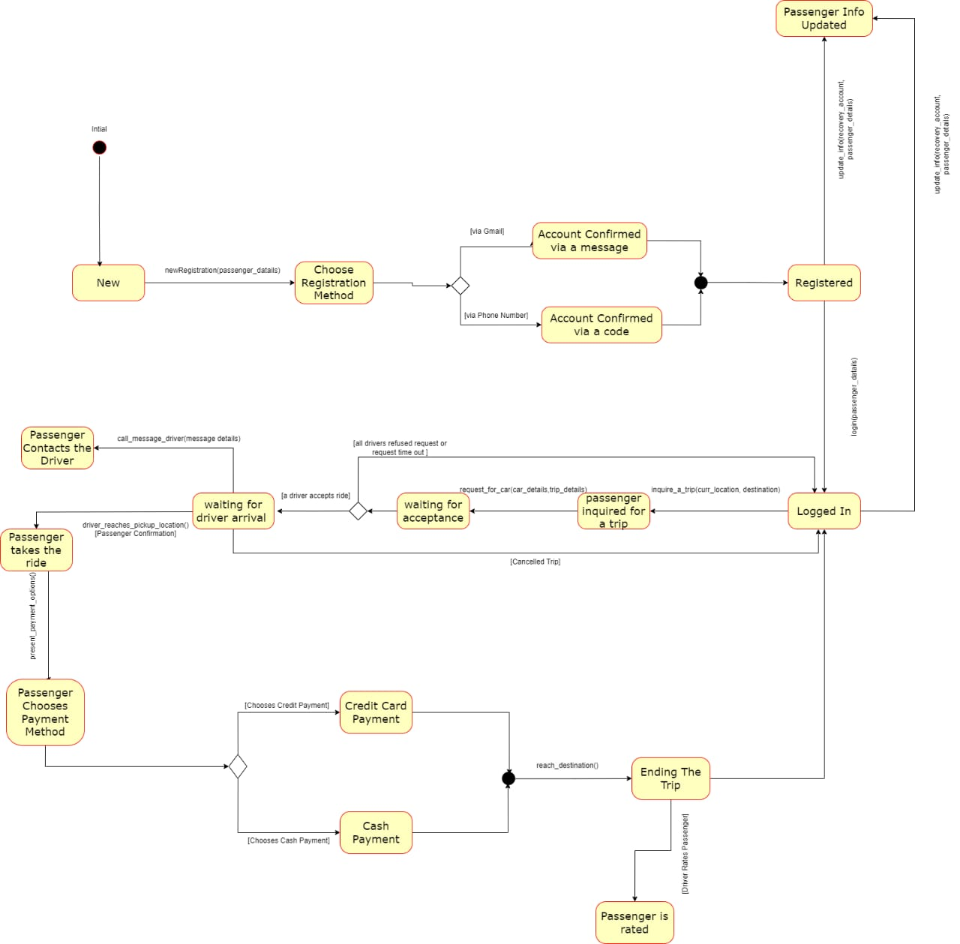

- The Driver
- 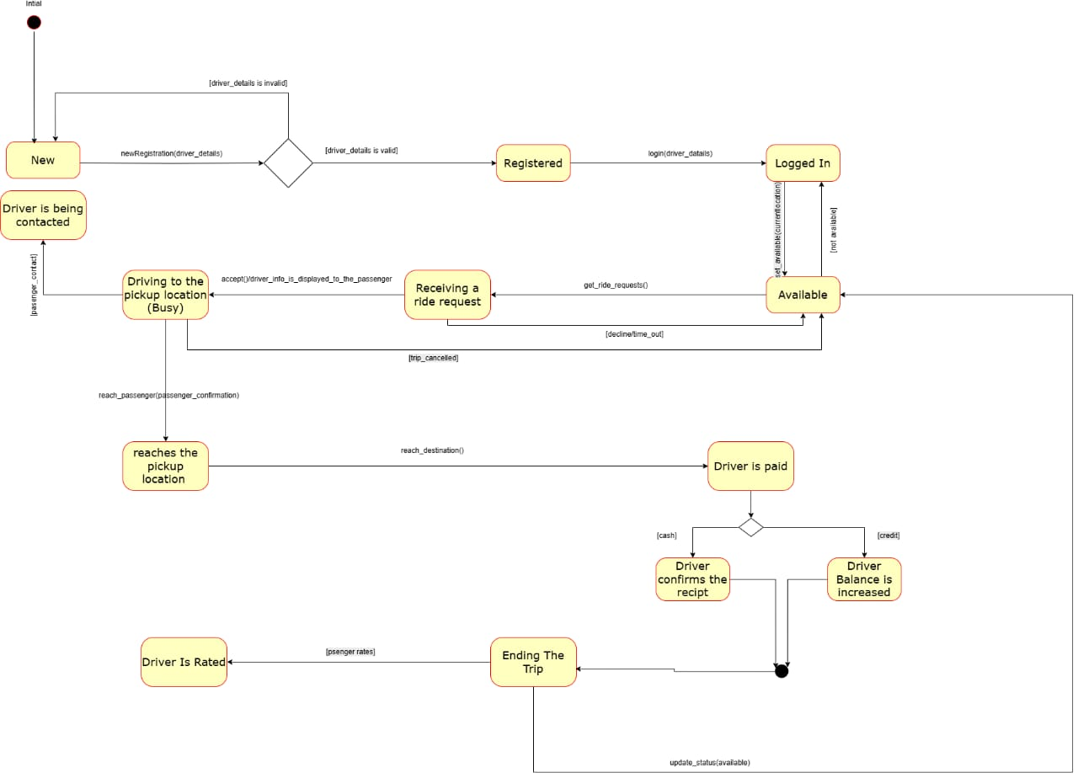
- The Trip
- 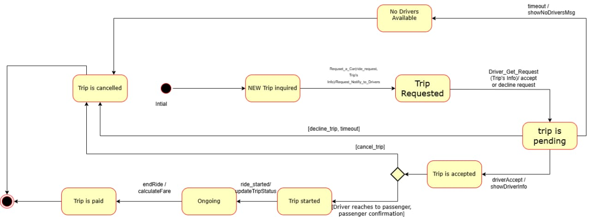

Activity Diagrams
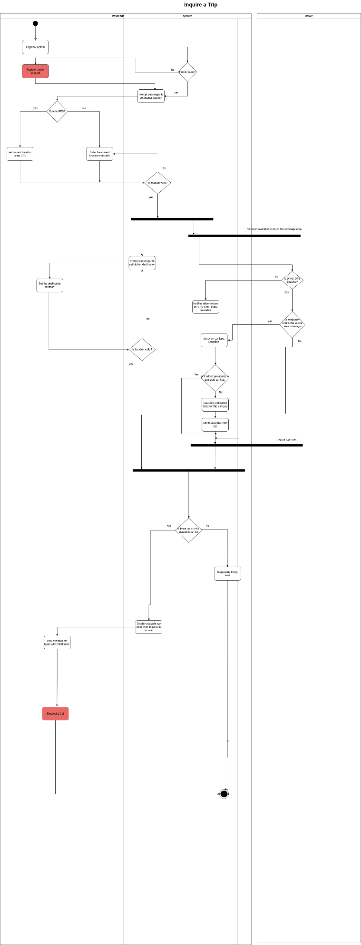
- Inquire a ride

- Request a Car
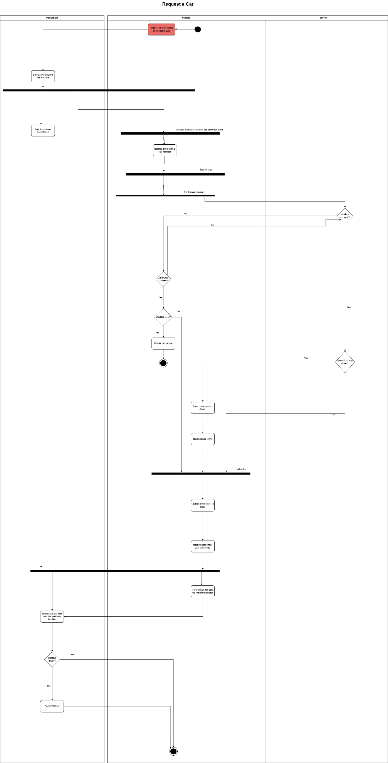

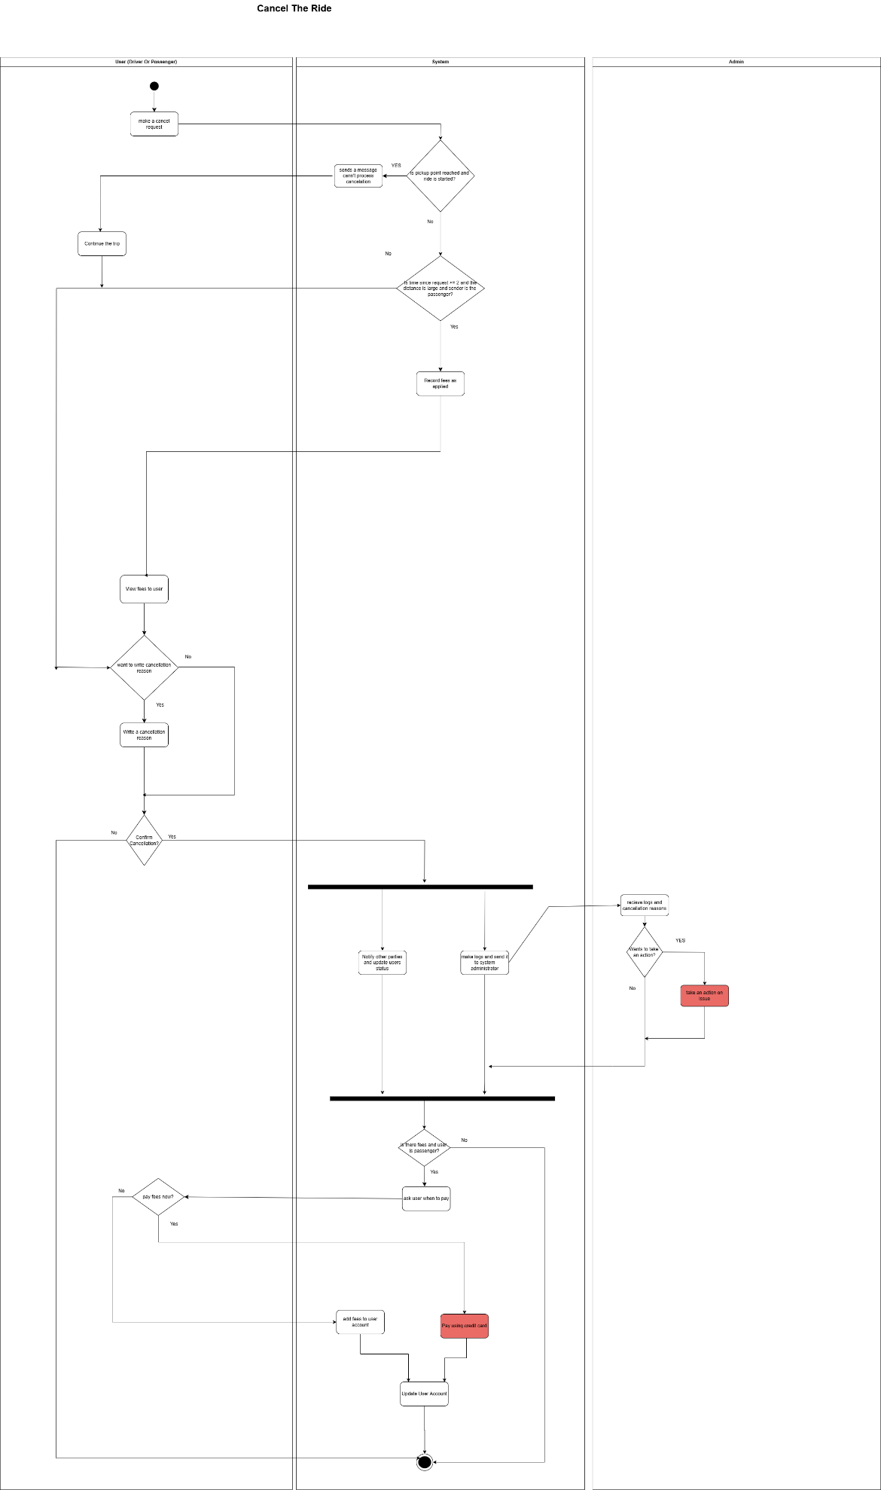
Cancel the Ride

- Pay the Ride
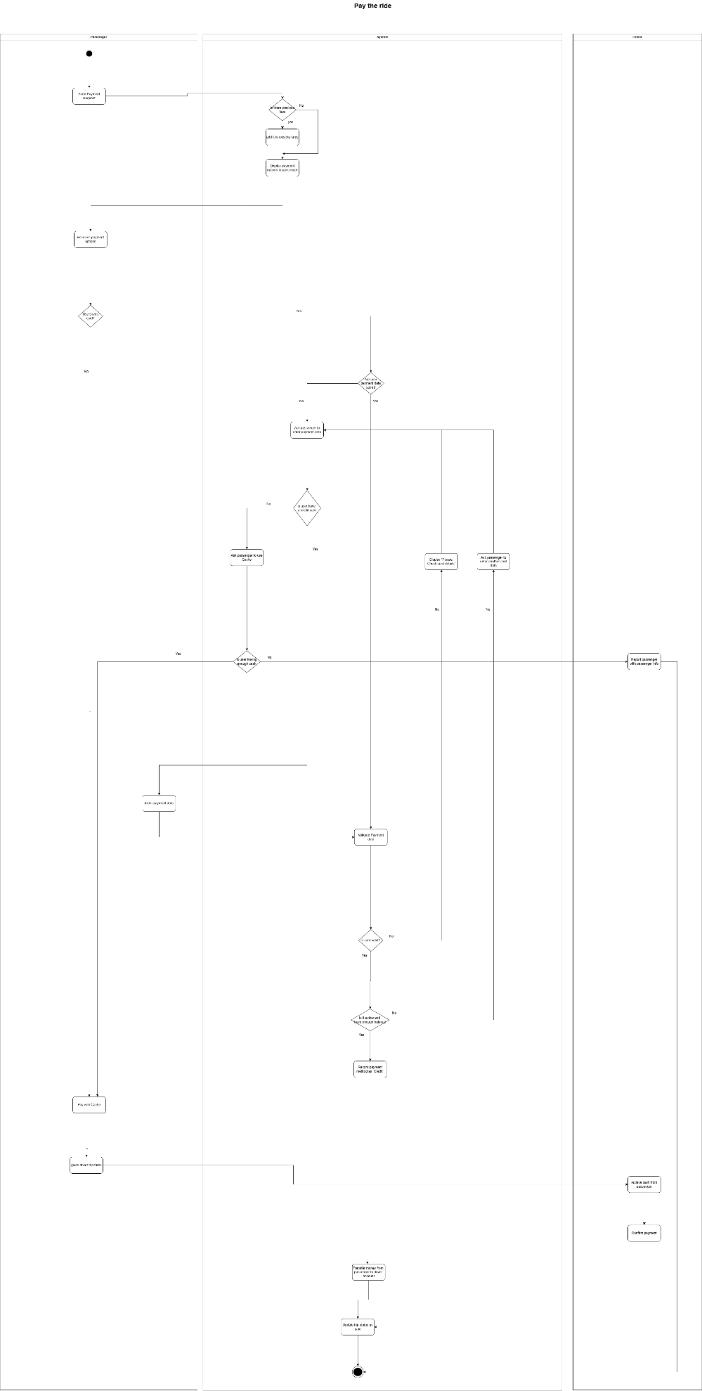

- Rate User
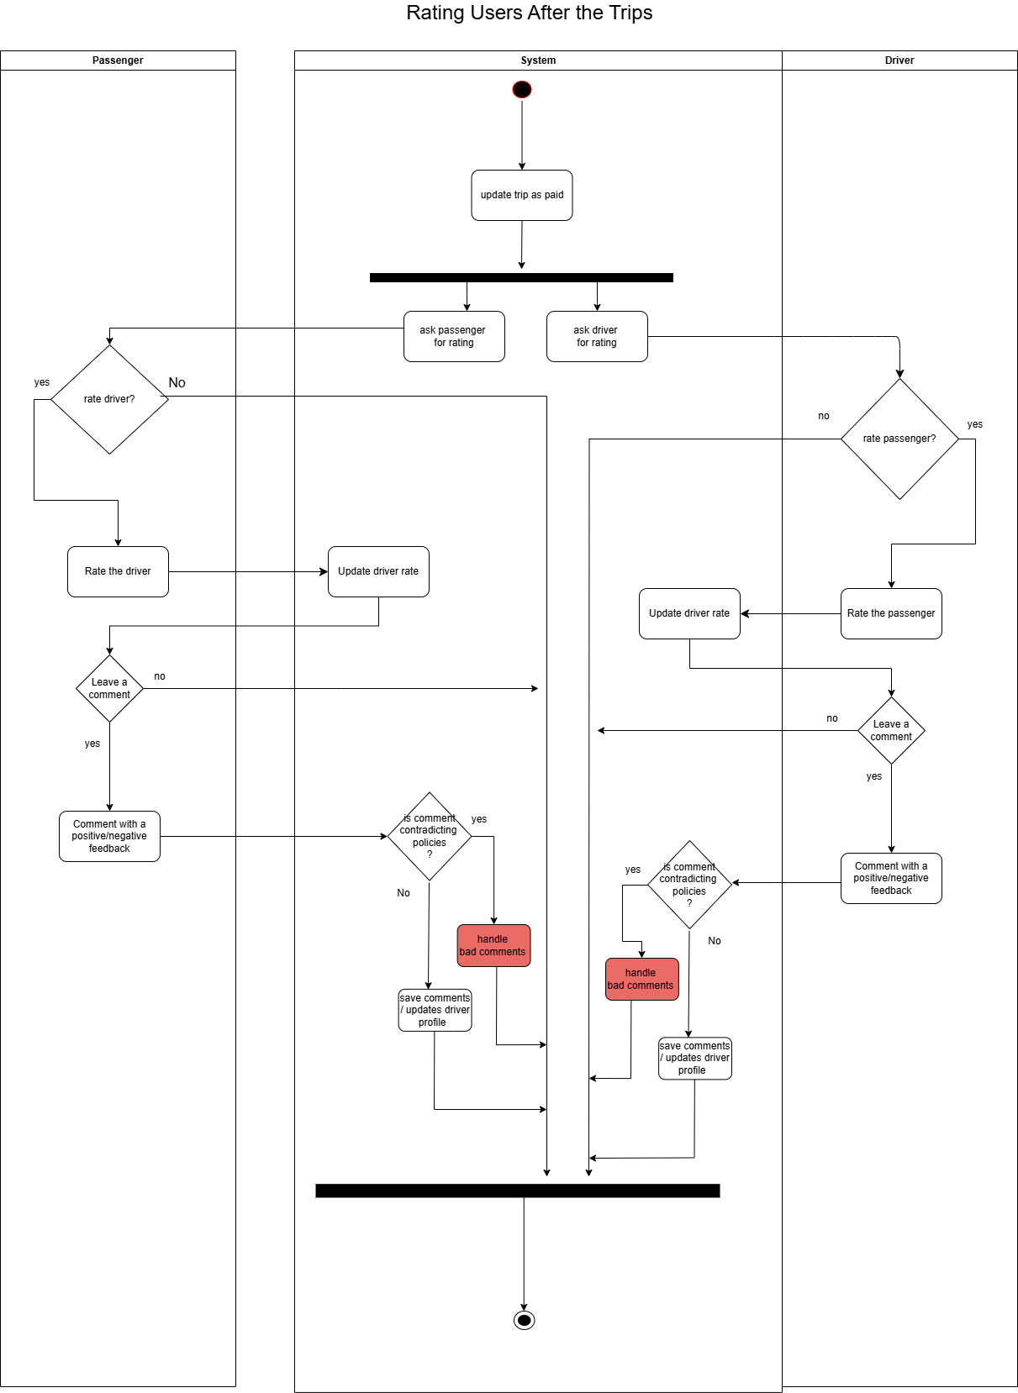

- Take actions on issues
Take an Action on issue:
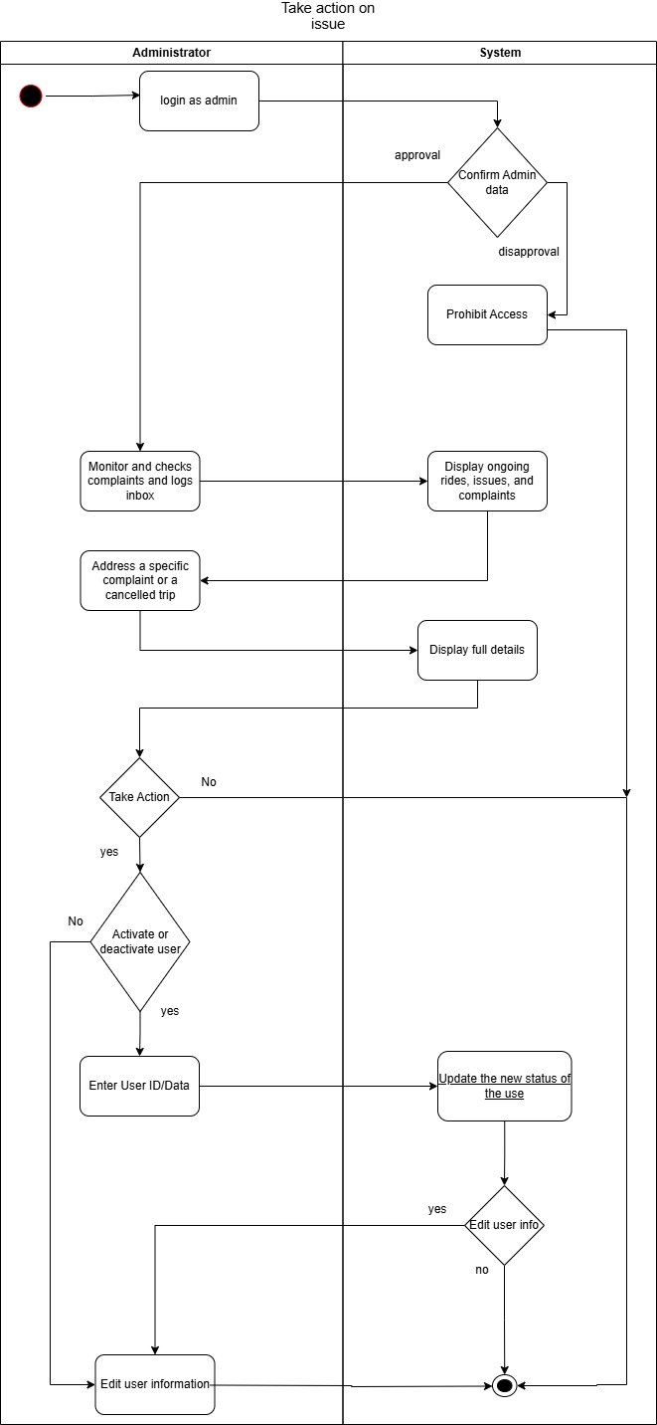

Sequence diagram:
Driver's Sequence Diagram:
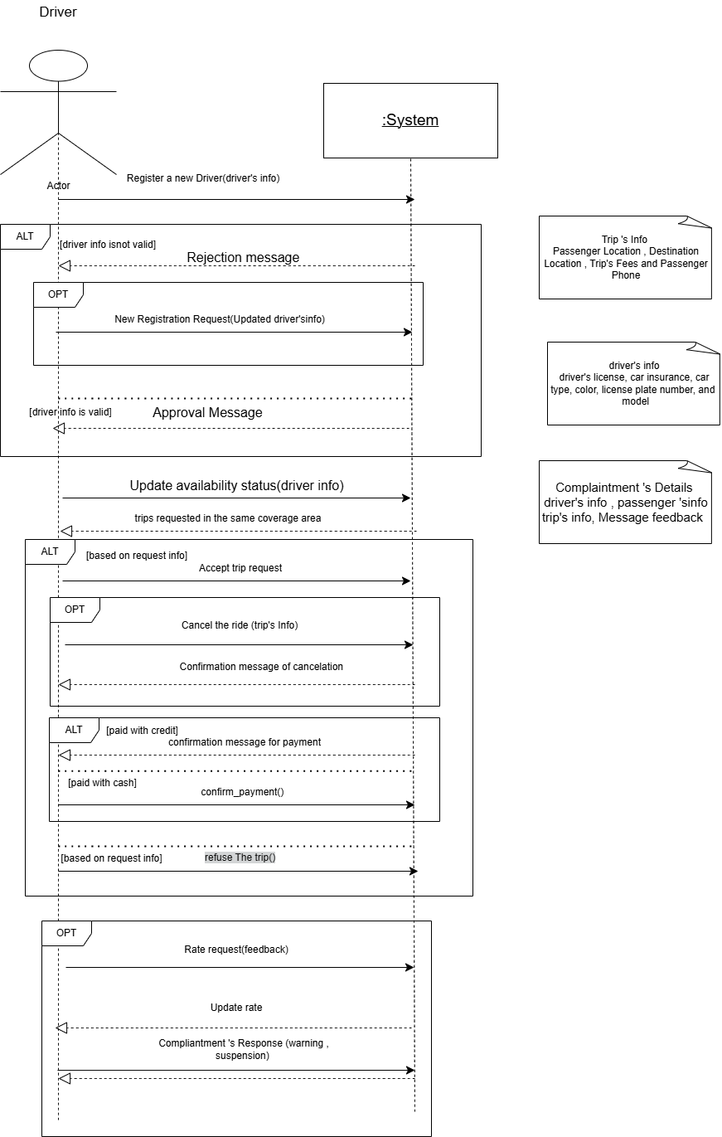

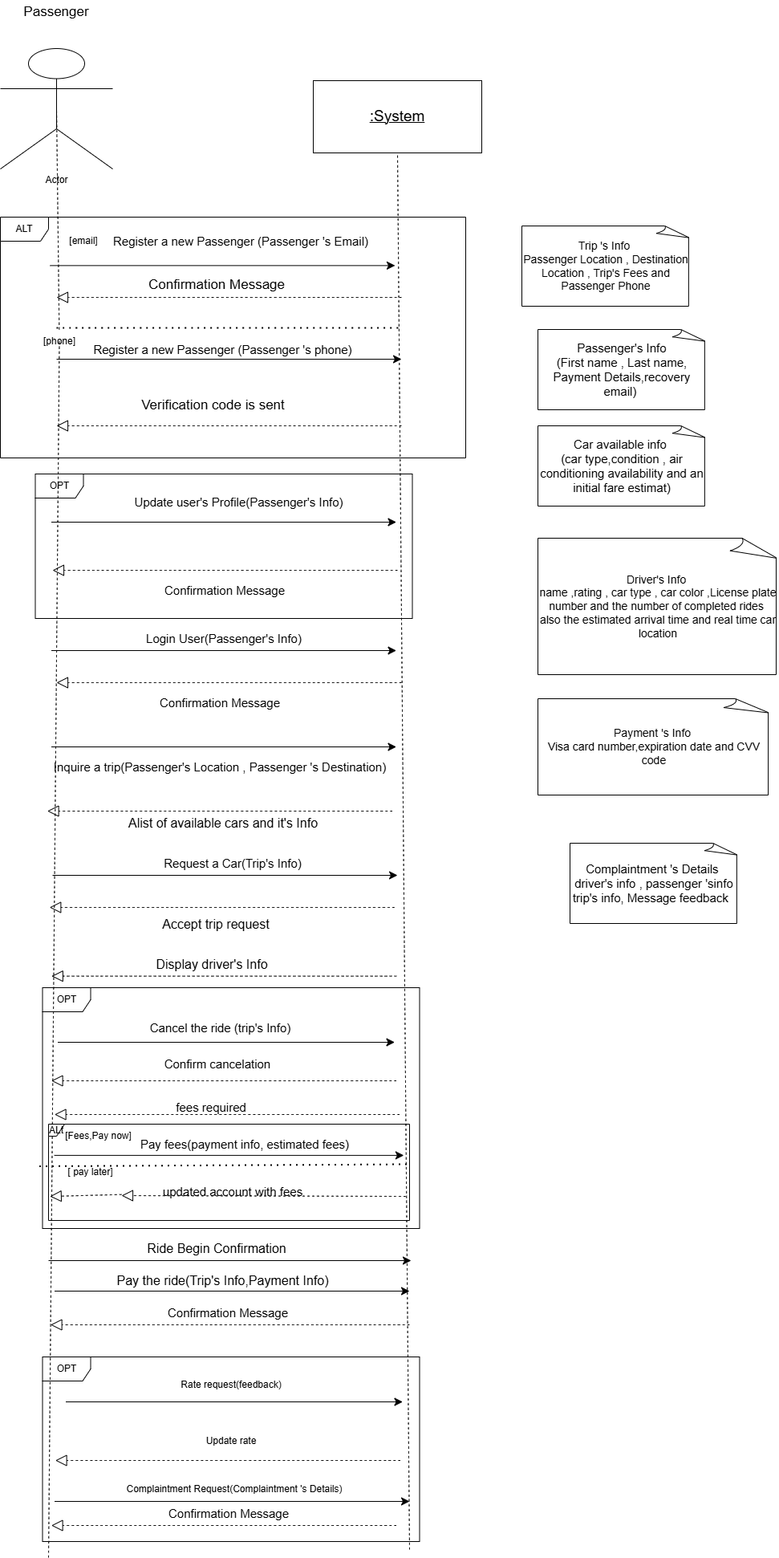
Passenger'sSequence Diagram:

Administrator 'sSequence Diagram:
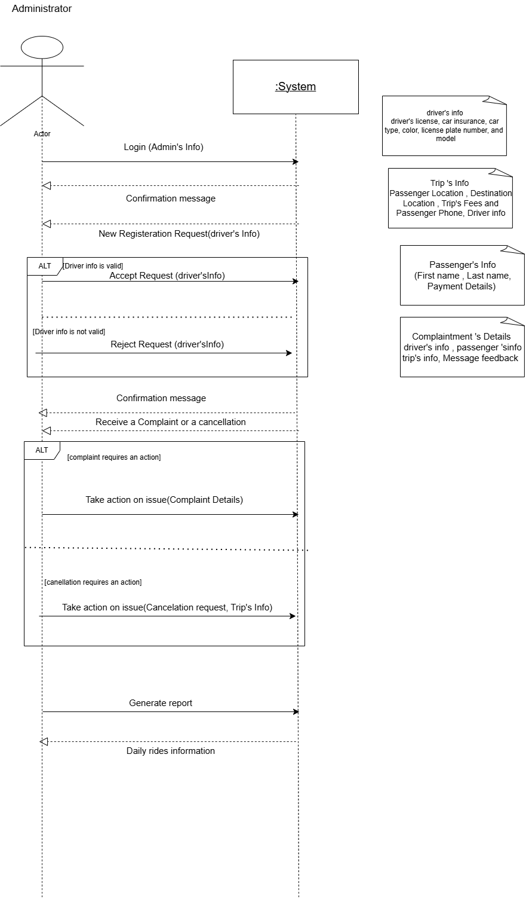

Context DFD:
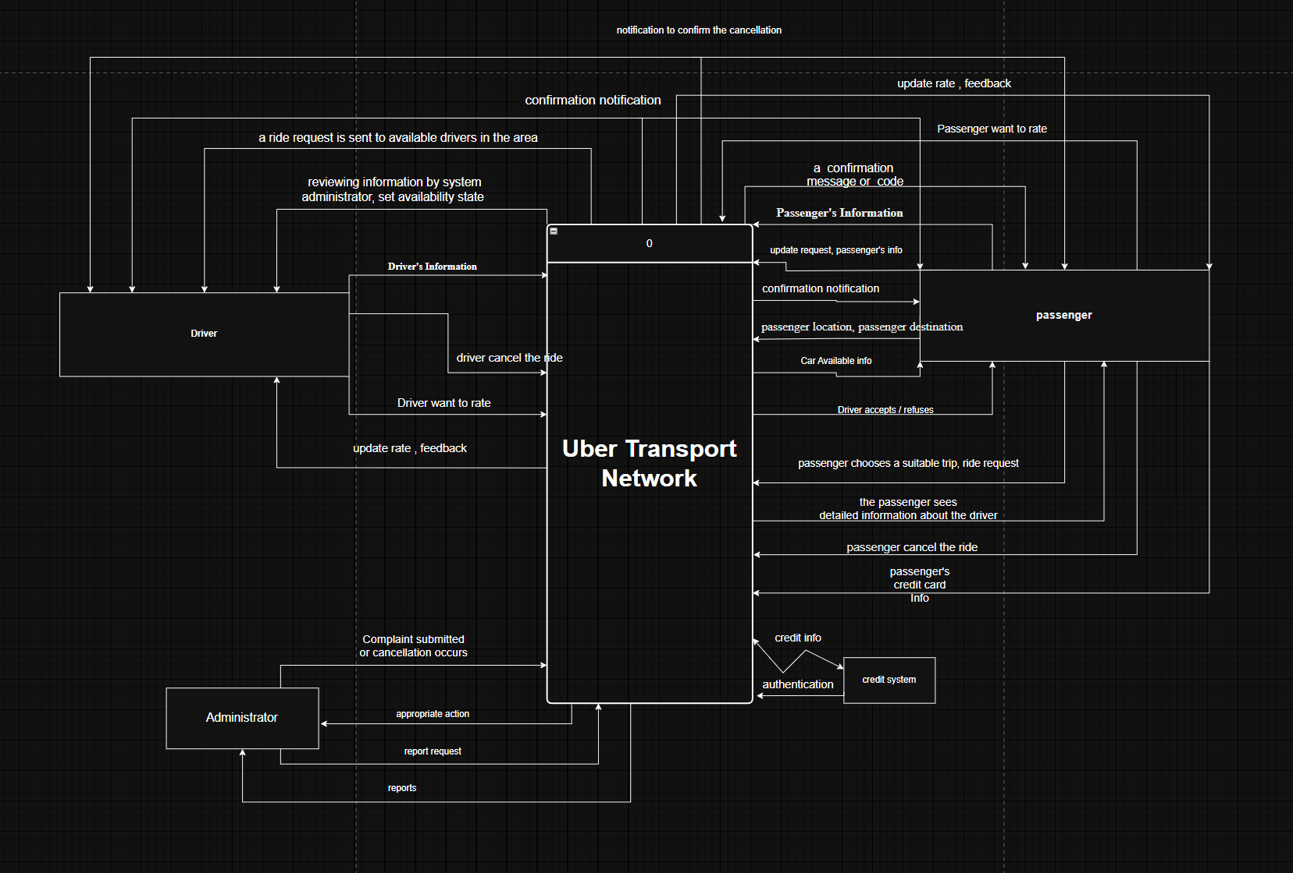

Overview DFD:
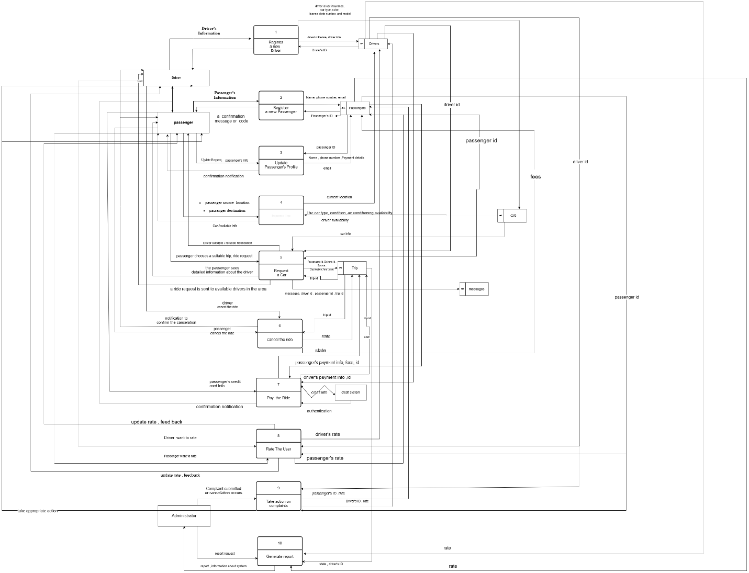

Inquire a Trip DFD: 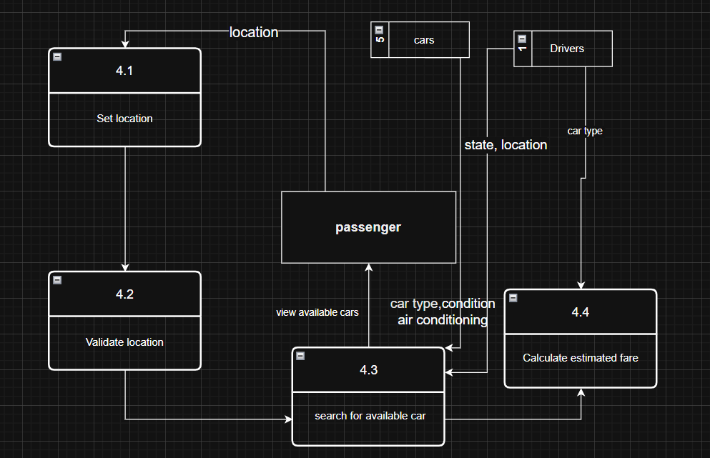

Request a car DFD:
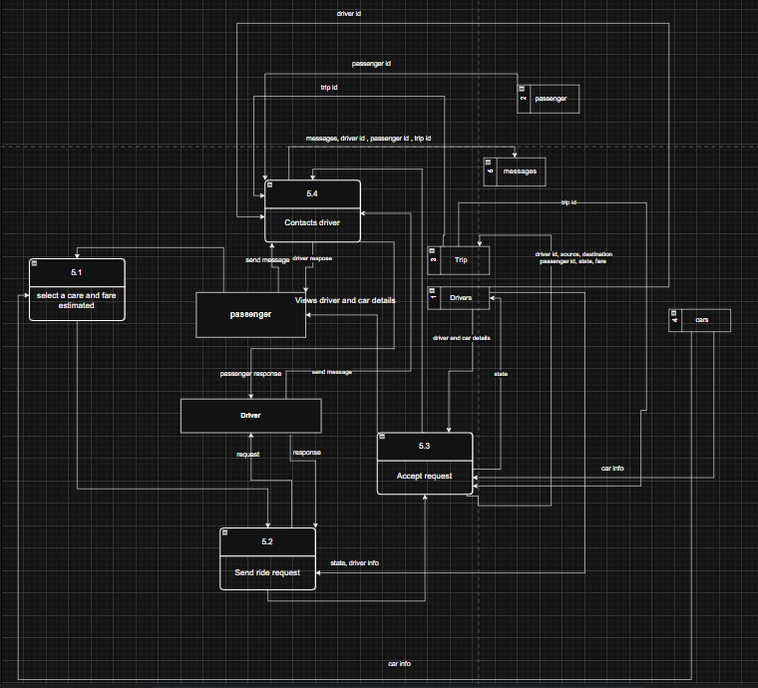

Pay the Ride DFD:
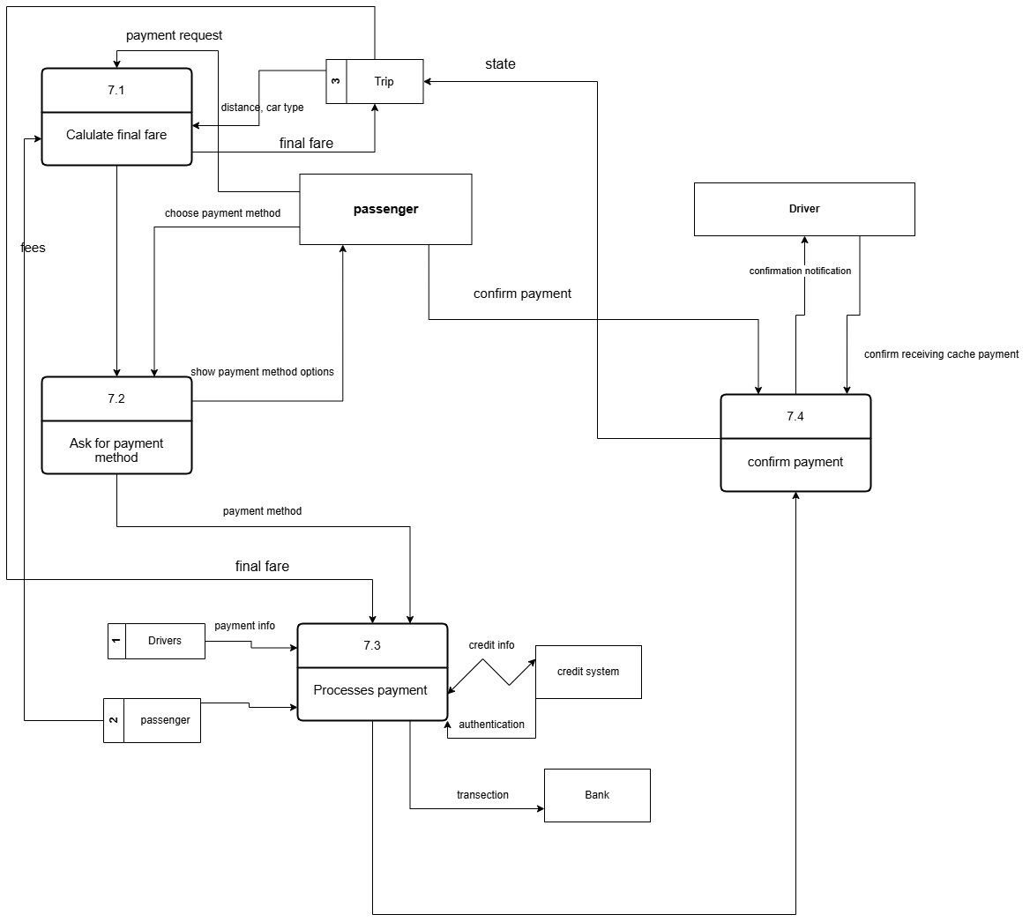

Cancel the Ride DFD:
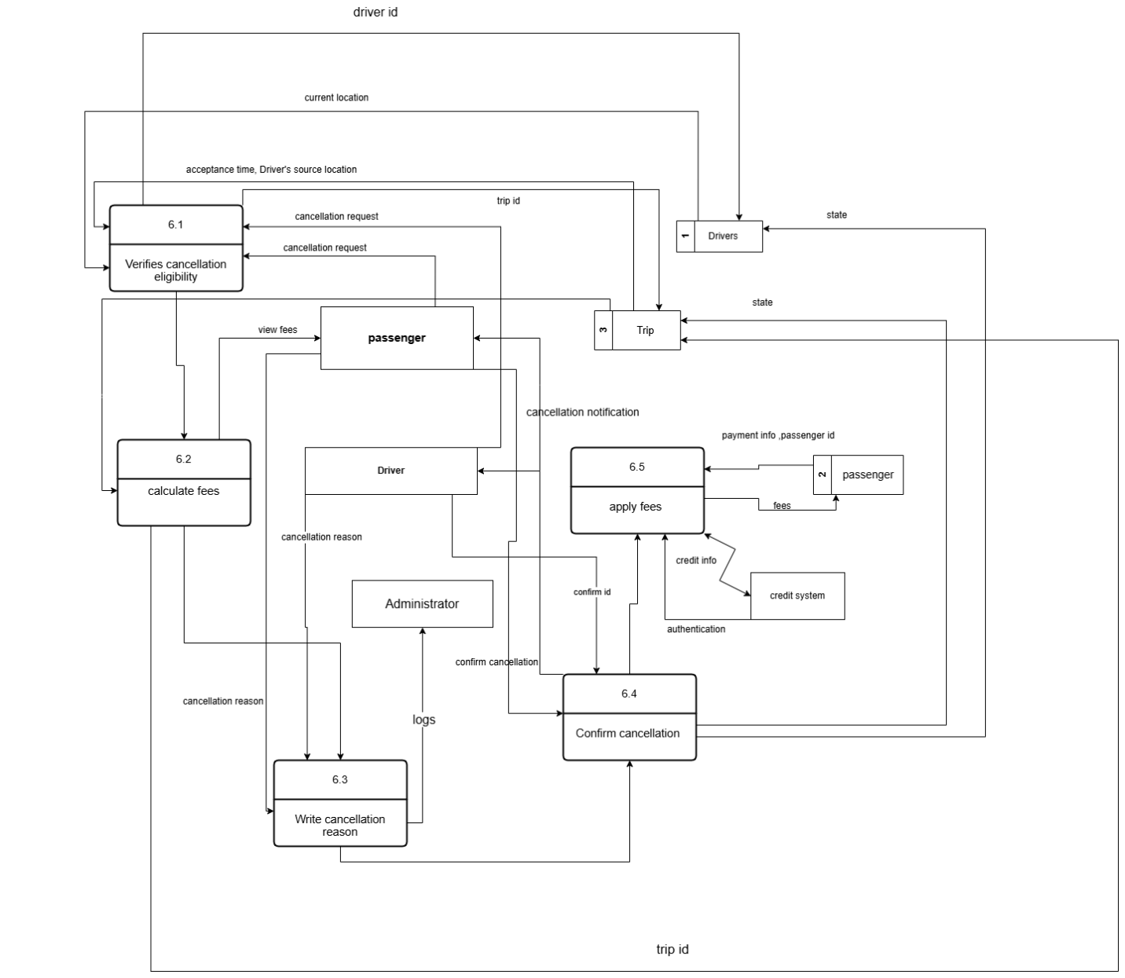

Gantt Chart of Project Completion
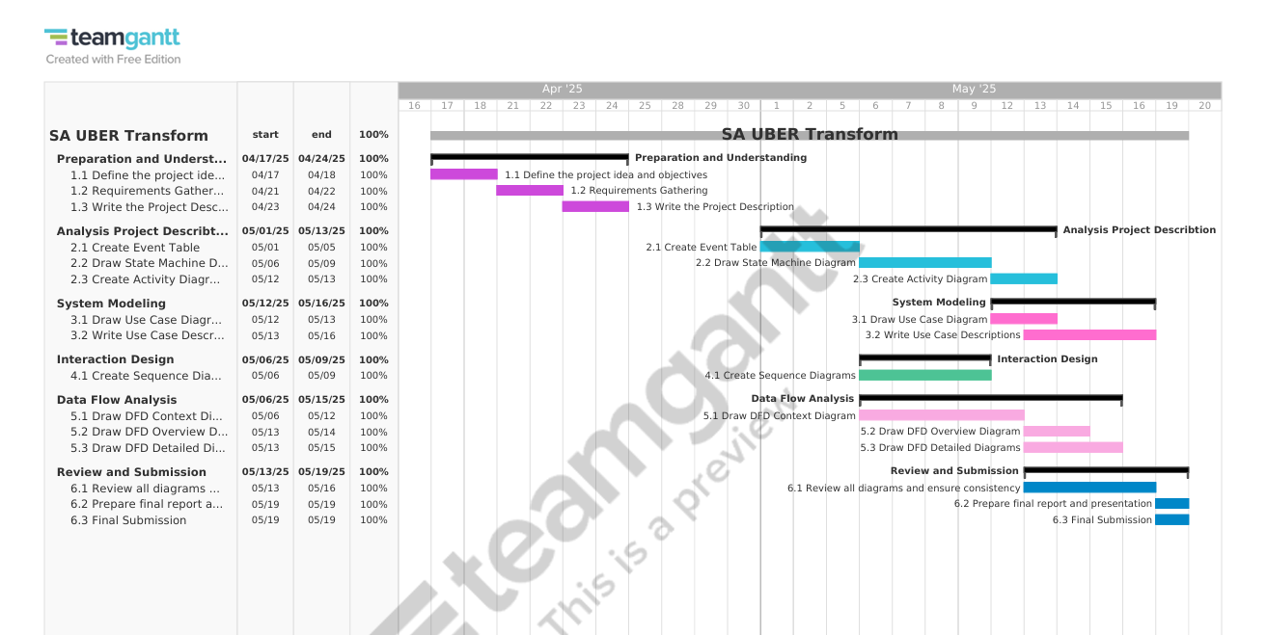
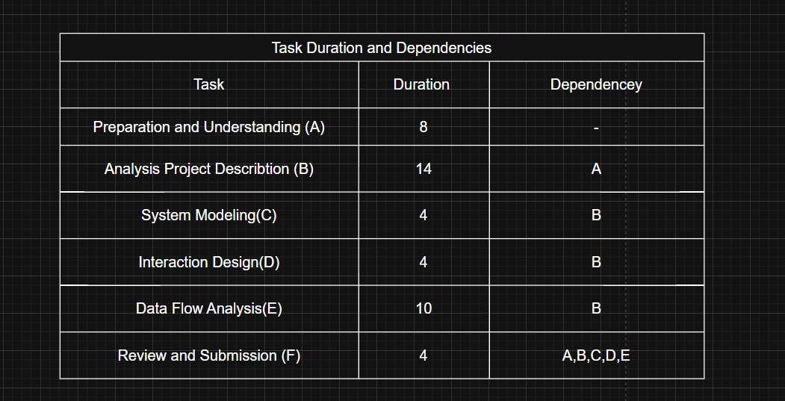

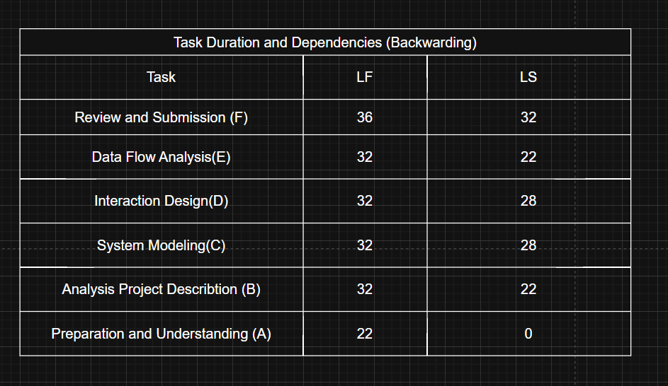
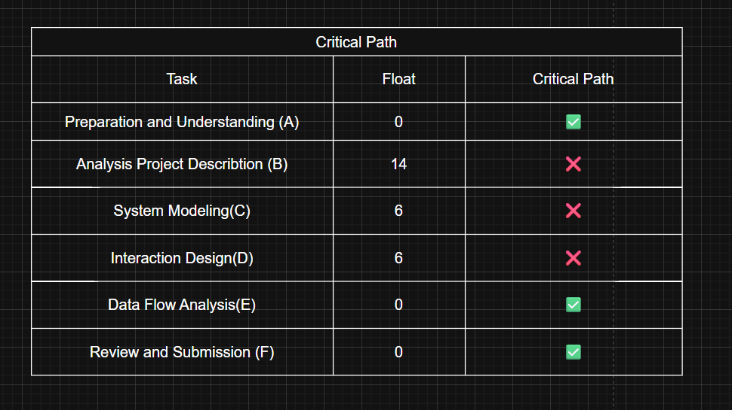

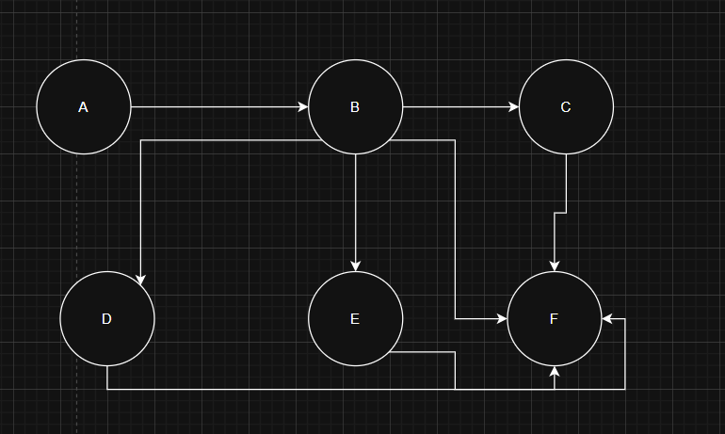

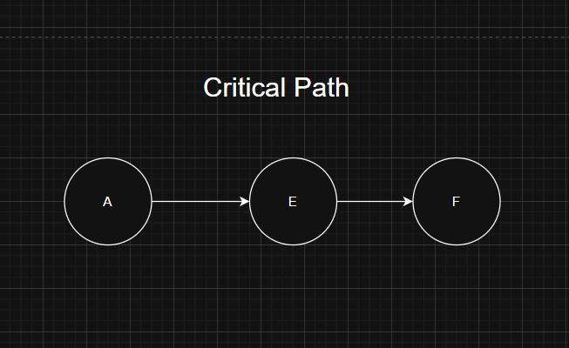

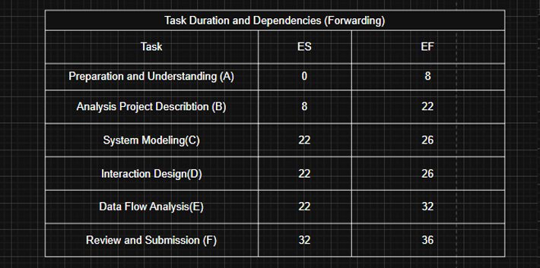

Questionnaire:
Introduction
Thank you for participating in our research on improving transportation services. Your feedback will help us develop a more user-friendly and efficient transportation application. This questionnaire should take approximately 10-15 minutes to complete. Your responses will remain anonymous and confidential.
Section 1: Transportation Habits and Preferences
- How often do you use transportation services (taxis, rideshares, etc.)?
  - Daily
  - Several times a week
  - Once a week
  - A few times a month
  - Rarely or never
- What factors influence your choice of transportation service? (Select all that apply)
  - Convenience
  - Price
  - Wait time
  - Vehicle quality
  - Driver ratings
  - Safety features
  - Other (please specify): ________________
- What time of day do you typically use transportation services? (Select all that apply)
  - Morning (6 AM - 12 PM)
  - Afternoon (12 PM - 5 PM)
  - Evening (5 PM - 10 PM)
  - Late night (10 PM - 6 AM)
Section 2: Application Features and Usage
- How would you primarily use our transportation application?
  - As a passenger
  - As a driver
  - Both as a passenger and driver
- Which method do you prefer for account registration?
  - Email address
  - Phone number
  - Social media account
  - No preference
- How comfortable are you with providing the following information during registration? (Rate on a scale: Very Comfortable, Comfortable, Neutral, Uncomfortable, Very Uncomfortable)
  - Phone number
    - Very Comfortable, Comfortable, Neutral, Uncomfortable, Very Uncomfortable
  - Email address
    - Very Comfortable, Comfortable, Neutral, Uncomfortable, Very Uncomfortable
  - Full name
    - Very Comfortable, Comfortable, Neutral, Uncomfortable, Very Uncomfortable
  - Payment information
    - Very Comfortable, Comfortable, Neutral, Uncomfortable, Very Uncomfortable
- For setting your pickup location, which option would you prefer?
  - Automatic GPS detection
  - Manual pin placement on map
  - Entering an address manually
  - Selecting from saved locations
Section 3: Ride Experience and Preferences
- When selecting a ride, which information is most important to you? (Rank from 1-5, with 1 being most important)
  - Estimated fare 1 2 3 4 5
  - Driver rating 1 2 3 4 5
  - Vehicle type 1 2 3 4 5
  - Estimated arrival time 1 2 3 4 5
  - Additional features (air conditioning, etc.) 1 2 3 4 5
- What details about the driver would you like to see before the ride begins?
  - Name and photo
  - Rating
  - Vehicle information
  - Number of completed rides
  - All of the above
  - Other (please specify): ________________
- How important is the ability to contact your driver before pickup?
  - Very important
  - Important
  - Somewhat important
  - Not important
Section 4: Payment and Security
- Which payment methods would you prefer to use? (Select all that apply)
  - Credit/debit card
  - Cash
  - Digital wallet (Apple Pay, Google Pay, etc.)
  - In-app balance/wallet
  - Other (please specify): ________________
- How do you feel about storing payment information in the application?
  - Completely comfortable
  - Comfortable with proper security measures
  - Neutral
  - Somewhat uncomfortable
  - Very uncomfortable
- What security features would make you feel safer when using the application? (Select all that apply)
  - Real-time location sharing with friends/family
  - Emergency contact button
  - Driver background verification indicators
  - Two-factor authentication for account access
  - Other (please specify): ________________
Section 5: Feedback and Rating System
- How likely are you to rate drivers after completing a ride?
  - Always
  - Most of the time
  - Sometimes
  - Rarely
  - Never
- What aspects of the rating system do you find most valuable?
  - Star rating
  - Written comments/feedback
  - Specific categories to rate (cleanliness, driving, etc.)
  - Option to remain anonymous
  - Other (please specify): ________________
Section 6: Additional Features
- Which of these additional features would enhance your experience? (Select all that apply)
  - Scheduled rides in advance
  - Favorite drivers list
  - Multiple stops during a trip
  - Shared/pooled rides with other passengers
  - Loyalty program or rewards
  - Other (please specify): ________________
- What concerns might you have about using a new transportation application?
[Open text field]
Section 7: Demographics (Optional)
- What is your age group?
  - 18-24
  - 25-34
  - 35-44
  - 45-54
  - 55-64
  - 65+
  - Prefer not to say
- How would you describe the area where you live?
  - Urban
  - Suburban
  - Rural
  - Other
Thank You
Thank you for completing this questionnaire. Your feedback is valuable and will help us develop a transportation application that better meets our users’ needs. If you have any additional comments or suggestions, please share them below:
_____________________________

Conclusion
The Uber Transport Network System offers a smart, user-friendly solution for modern transportation needs.
It ensures safety, convenience, and efficiency for both drivers and passengers.
With real-time tracking, secure payment, and user feedback, the system aims to deliver a high-quality and reliable service.
Administrative tools and reports help maintain system integrity and support continuous improvement.

